Isometric Exercises for Strengthening & Relaxing Your Neck Muscles

These exercises may be done while standing, sitting, or lying on your back. The sitting position is usually the easiest. Repeat each exercise 6 times per day. After the exercise you will first feel a deep relaxation of the neck muscles and moreover your neck muscles will be strengthed.

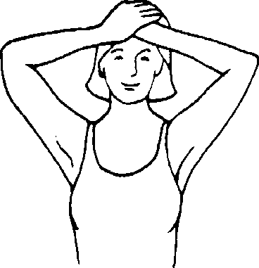
Neck Flexing
Bend your neck slightly forward and put your hand on your forehead. Try to bend your head forward while pushing back with your hand. Hold for 20-30 seconds.

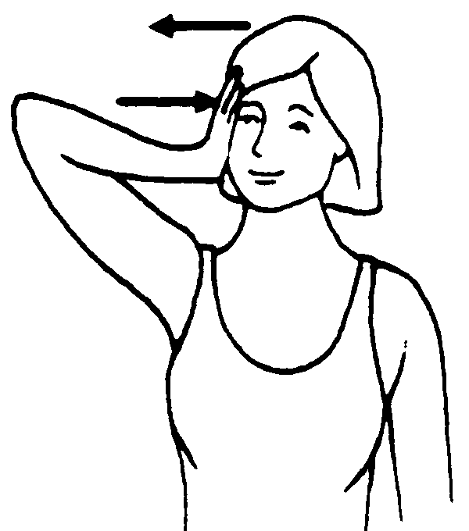
Neck Extension
Keep your up and your neck straight and place your hands at the back of your head. Try to push your head backwards while pushing forward with your hands. Hold for a count of 20-30 seconds.

Side Bending
Keep your head straight and your chin level. Put your right hand on the right side of your head. Try to bring your head down to your right shoulder while pushing up with your right hand. Hold for 20-30 seconds.
- Repeat the Side Bending, but to the side with your left hand.

Rotation
Put your left hand at chin level and turn your head slightly to the right. Put your right hand on the right side of your face. Turn your head to the right while pushing it back with your right hand. Hold for a count of 20-30 seconds.
- Repeat the Rotation Exercise, but on the left side of your and with left hand.

This information is handed over by doctor´s practise Bitzer & colleagues for supporting
the treatment with personal exercises.

